

[**Amanda.Stanley.Artist@gmail.com**](mailto:Amanda.Stanley.Artist@gmail.com)

(817)239-3045

[www.amandastanleyportfolio.weebly.com](http://www.amandastanleyportfolio.weebly.com)

www.artstation.com/amandastanley

Skills

Work Experience

* Unity
* Marmoset
* Toon Boom
* Substance Painter
* Microsoft Office
* Autodesk 3DS Max/ Maya
* Mudbox/ Zbrush
* Adobe Suite
* Unreal Engine 4
* Perforce
* MS Office Suite
* Matte Painting
* Concept Design
* Traditional Artist
* Modularity Workflows
* Storyboarding
* Game Documentation
* Texture Artist
* Digital Painting
* Digital Sculpting
* Illustrator
* Scrum/ Agile
* QA Testing/ Playtester
* Environment Design
* Prop Design
* Hard Surface Modeling
* Organic Modeling
* UV Mapping
* PBR Texturing

Skills Software

***Lead Game Artist***

***Game Artist***

***Game Artist***

***Sole Proprietor***

***Lead Environment***

***Artist***

***Environment Artist***

* Environment and Prop Models
* Assisted in Concept Design
* UV Mapping/ Texture Artist
* Technical Proficiency in Unreal4
* Matte Painting

**Awards**

* **Best Visual Quality**

Intel University Games Showcase GDC 2016

**Games**

* **Supercrush**

Ship Date: Spring 2014

**Games**

* **Battle of the Banderas**

Ship Date: Spring 2015

**Games**

* **EscarGo!**

Ship Date: Spring 2015

**Games**

* **Inua**

Ship Date: Spring 2016

* Technical Proficiency in Unity
* Created and Finalized Production Materials
* Technical Proficiency in Unreal4
* Matte Painting
* Technical Proficiency in Unreal 4
* Production Materials
* HUD icon
* Technical Proficiency in Unity
* Scrum Lead
* Organic Modeling Assets
* UV Mapping/ Texture Artist
* Material Setup in Unreal4
* 2D Environment Decals

Education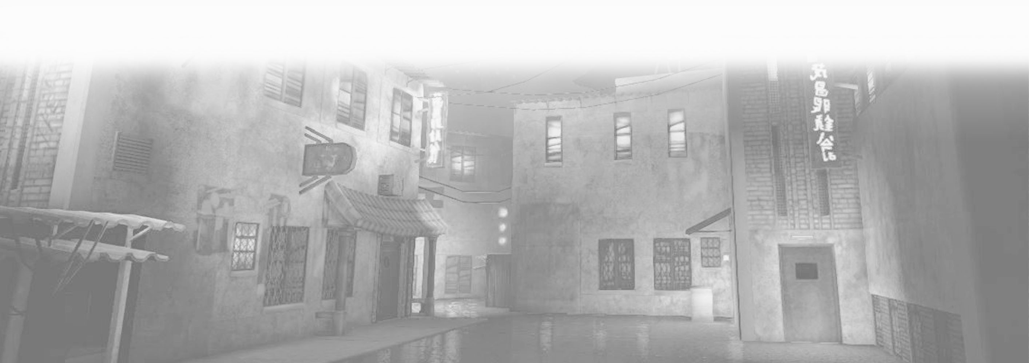

* Fine Arts, Graphic Communications, Gaming Design

Arlington, TX

**Saturday Morning Studios Responsibilities 1/2014- 5/2014**

**Azul Studios Responsibilities 6/2014- 10/2014**

**Rogue Productions Responsibilities 6 /2014- 10/2014**

**Betrayal Games Responsibilities 1/2015- 5/2015**

**A Staircase Above Studio Responsibilities 6/2016- 7/2017**

**Moon Lightning Designs Responsibilities 7/2017- Present**

**Games**

* **S.A.R**

Ship Date: Canceled

* 2D and 3D Game Artist
* 3D Modeler and Print Setup
* Illustrator

**Games**

* **10,000 Goblins**

Plano, TX

**Guildhall at SMU Masters of Interactive Technology Dec 2015**

**University of Texas at Arlington Bachelor of Fine Arts Dec 2012**

* Lead Environment Concept Design
* Headed 2D Game Environment
* Skybox
* Headed 2D Game Assets
* Produced Concept Artwork
* Controlled 2D Environment

Design

* Environment and Prop Models
* Assisted in Concept Design
* UV Mapping/ Texture Artist
* Specialization: Environment and Prop Art

**Games**

* **Inua**

Ship Date: Spring 2016

**Awards**

* **Best Visual Quality**

Intel University Games Showcase GDC 2016